**Super Works Product Store**

* **Introduction**

An e-commerce company named SuperWorks is launching their new online shopping webapp. Following are the features the web app should have:

1. User should be able to add items to cart.

2. Clicking on the Cart button the user should be able to navigate to cart details page.

* **Planning**

Of course before starting actually coding you need to have a clear picture in your mind of: how exactly the thing you want to build should look and how it should behave.

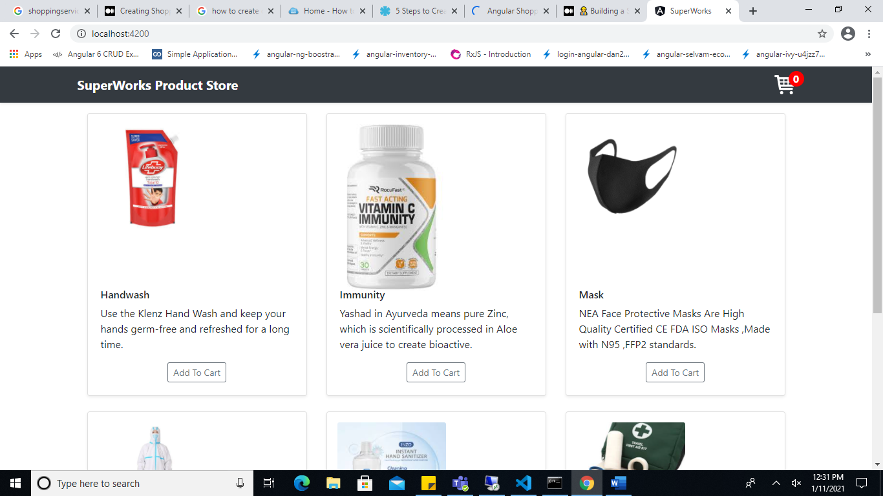

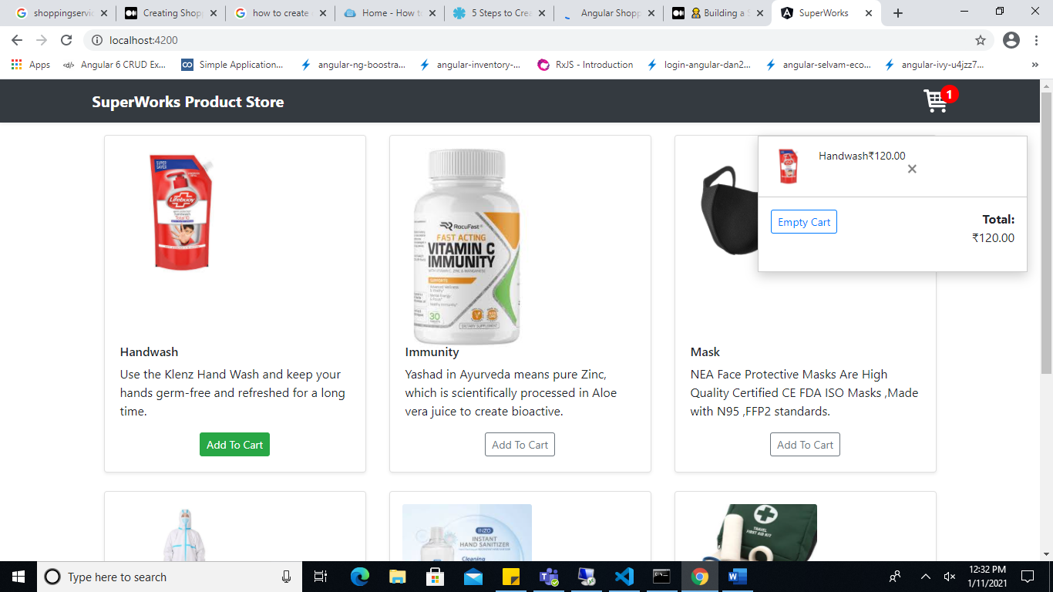\

as you can see - the design consist of two parts: first one is product list and right top corner popup - is the shopping cart itself.

* Pressing on each Add to Cart button of product`s - will make the product appear inside shopping cart.
* Each product instance at shopping cart has a product price, product name and product image.
* As per number of products added into cart it will calculate total of entire cart items.

getTotalPrice() {

let total = 0;

this.cartItems.map(item => {

total += item.price;

});

return total

}

* To remove added products into cart there are two options

1. Empty Cart item– On click of empty cart button it will make cart empty.

emptryCart() {

this.cartItems.length = 0;

this.products.map((item, index) => {

item.isAdded=false ;

});

}

1. Remove Cart item – On click of close button beside cart item name removes single cart item from cart list.

removeProductFromCart(productId) {

this.cartItems.map((item, index) => {

if (item.id === productId) {

this.cartItems.splice(index, 1);

}

});

this.products.map((item, index) => {

if (item.id === productId) {

item.isAdded=false ;

}

});

}

* **Technology Used :**

Angular Cli : ^10.0.4

Typescript : ^ 3.9.4

* **Git URL**

https://github.com/Snehal-27/SuperWorks